

National College of Ireland

Honours in Computing

Software Development

2024/2025

Karl Miller

X21522489

X21522489@student.ncirl.ie

Tales of Atheria

Technical Report

Contents

Executive Summary 2

1.0 Introduction 2

1.1. Background 2

1.2. Aims 2

1.3. Technology 2

1.4. Structure 2

2.0 System 2

2.1. Requirements 2

2.1.1. Functional Requirements 2

2.1.1.1. Use Case Diagram 2

2.1.1.2. Requirement 1 <Name of requirement in a few words> 2

2.1.1.3. Description & Priority 2

2.1.1.4. Use Case 3

2.1.2. Data Requirements 4

2.1.3. User Requirements 4

2.1.4. Environmental Requirements 4

2.1.5. Usability Requirements 4

2.2. Design & Architecture 4

2.3. Implementation 4

2.4. Graphical User Interface (GUI) 4

2.5. Testing 4

2.6. Evaluation 4

3.0 Conclusions 4

4.0 Further Development or Research 4

5.0 References 5

6.0 Appendices 5

6.1. Project Proposal 5

6.1. Ethics Approval Application (only if required) 5

6.2. Reflective Journals 5

6.3. Invention Disclosure Form (Remove if not completed) 5

6.4. Other materials used 10

# Executive Summary

Max 300 words. Summarise the key points of the report. Restate the purpose of the report, highlight the major points of the report, and describe any results, conclusions, or recommendations from the report.

# Introduction

## Background

I’ve wanted to create a videogame for many years now since they were a big part of my childhood and I would like to do the same for the kids in the future if possible.

## Aims

I aim to create a Rougelite Videogame to the best of my abilities with the time and resources I have with plenty of depth and replayability

## Technology

The software I will be using is called RPGmaker MV, By the name its primarly used for making Role playing games(RPG’s) however if you know how to use the software well you can create a wide variety of games.

## Structure

Provide a brief overview of the structure of the document and what is addressed in each section.

# System

## Requirements

All requirements should be verifiable. For example, experienced controllers shall be able to use all the system functions after a total of two hours training. After this training, the average number of errors made by experienced users shall not exceed two per day.

## Functional Requirements

This section lists the functional requirements in **ranked order**. Functional requirements describe the possible effects of a software system, in other words, what the system must accomplish. Other kinds of requirements (such as interface requirements, performance requirements, or reliability requirements) describe how the system accomplishes its functional requirements. Each functional requirement should be specified in a format similar to the following:

Short, imperative sentence stating highest ranked functional requirement.

## Use Case Diagram

## Requirement 1 <Name of requirement in a few words>

The heading of this section should read, e.g., “Requirement 1: User registration” or “Requirements 1: Participant takes test”

## Priority

The priority. Describes how essential this requirement is to the overall system. (High, Medium, Low) High

## Use Case

Each requirement should be uniquely identified with a sequence number or a meaningful tag of some kind.

**Scope**

The scope of this use case is to explain the processes of battles.

**Description**

This use case describes the processes of the battles

**Use Case Diagram**

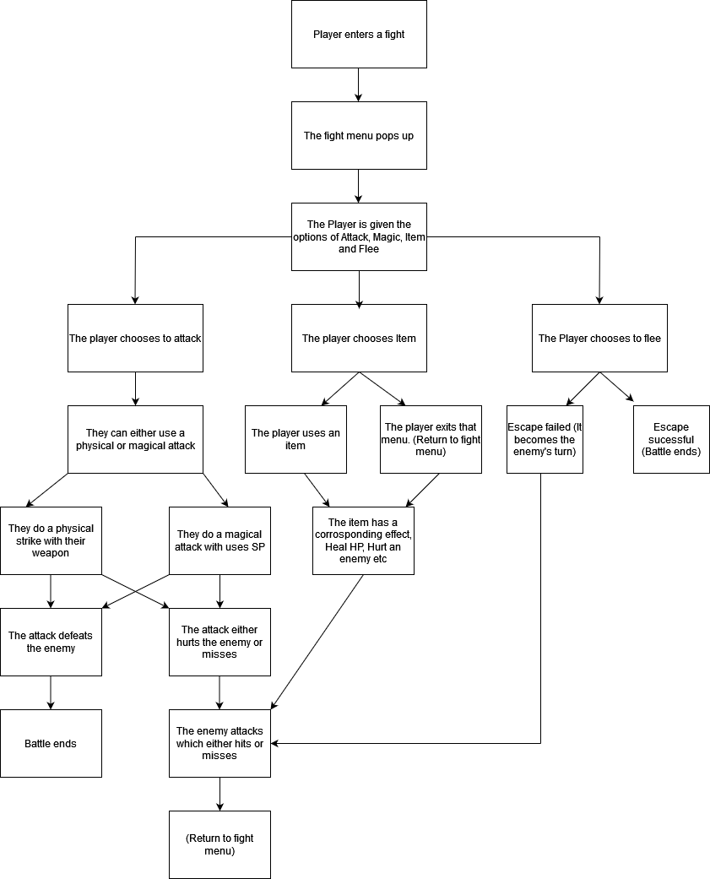

**Flow Description**

**Precondition**

The player must have entered a battle with an enemy

**Activation**

The player must currently be in a battle with an enemy.

**Main flow**

1. The system identifies that the battle has started
2. The system pulls up the battle menu for the User
3. The Player gets to pick the options of Attack, Magic, Item and Flee
4. The Player chooses Attack which then the Player can choose their target for the attack
5. The attack either hits or misses.

5i. If the attack hits it deals damage to the enemy

5ii. If the attack misses nothing happens

6. The Player’s turn ends and It becomes the enemy’s turn

7. The enemy’s attack either hits or misses

7i. If the enemy’s attack hits it deals damage to the Player

7ii. If the attack misses then nothing happens

8. Repeat flow until a different action is selected or the player or enemy dies.

**Alternate flow**

1. The player opens item menu
2. The Player chooses item from menu
3. The player uses an item
4. The item has a specific effect (Heal user, Harm enemy etc)
5. The system subtracts 1 instance of that specific item from the players inventory
6. The Player’s turn ends
7. It becomes the enemy’s turn
8. The enemy’s attack either hits or misses

5i. If the enemy’s attack hits it deals damage to the Player

5ii. If the attack misses nothing happens

1. Repeat flow until a different action is selected or the player or enemy

**Alternate flow**

1. The Player chooses the option to flee.
2. The system checks the speed of the Player and the Enemy
3. If the users speed is higher they can flee.
4. If the enemy’s speed is higher the flee attempt fails.

**Exceptional flow**

E1 : <title of E1>

1. The system …………..
2. The <Actor> ………….
3. The use case continues at position 4 of the main flow

**Termination**

The battle ending via the player defeating the enemy, Fleeing the fight or the player dying in battle.

**Post condition**

The system goes into a wait state until the next battle begins.

**List further functional requirements here, using the same structure as for Requirement1.**

**Scope**

The scope of this use case is to showcase the process of dying in the game.

**Description**

This use case describes the process of what happens when you die

**Use Case Diagram**

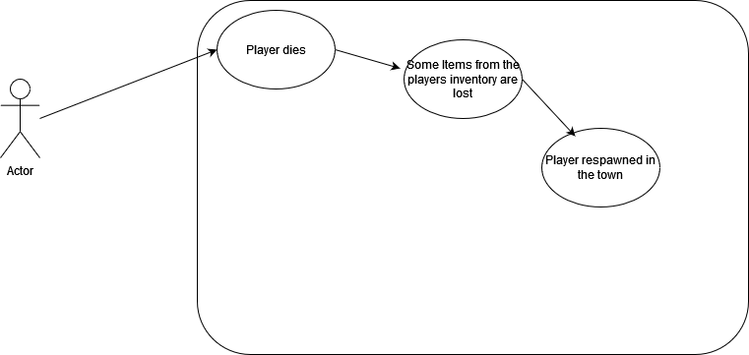

**Flow Description**

**Precondition**

The player must have entered a battle with an enemy

**Activation**

The player must have lost a battle with an enemy

**Main flow**

1. The player’s HP drops to 0
2. The System displays a message informing the Player they lose the fight
3. The system chooses at random 10% of their collected items to be removed from inventory.
4. The system respawns the player at their base
5. The System displays a message informing the Player of item lost from inventory

**Alternate flow**

1. The player tries to flee battle
2. The player fails to escape
3. The enemy hits the player
4. The player’s HP is dropped to 0
5. The Player dies
6. The system chooses at random 10% of their collected items to be removed from inventory.
7. The system respawns the player at their base
8. The System displays a message informing the Player of item lost from inventory

**Exceptional flow**

1. The system crashes.
2. The game reopens at home page.
3. The game autosaves.

**Termination**

The system respawns the player at their base and allows them to continue playing.

**Post condition**

The system goes into a wait state until the player falls in battle again or dies on some other way.

**List further functional requirements here, using the same structure as for Requirement1.**

**Scope**

The scope of this use case is to …….

**Description**

This use case describes the ………..

**Use Case Diagram**

Diagram should highlight actors and uses cases……..

**Flow Description**

**Precondition**

The system is in initialisation mode……..

**Activation**

This use case starts when an <Actor>…………

**Main flow**

1. The system identifies the ………….
2. The <Actor> …………...(See A1)
3. The system …………..(See E1)
4. The <Actor> ………….

**Alternate flow**

A1 : <title of A1>

1. The system …………..
2. The <Actor> ………….
3. The use case continues at position 3 of the main flow

**Exceptional flow**

E1 : <title of E1>

1. The system …………..
2. The <Actor> ………….
3. The use case continues at position 4 of the main flow

**Termination**

The system presents the next ……….

**Post condition**

The system goes into a wait state

**List further functional requirements here, using the same structure as for Requirement1.**

**Scope**

The scope of this use case is to …….

**Description**

This use case describes the ………..

**Use Case Diagram**

Diagram should highlight actors and uses cases……..

**Flow Description**

**Precondition**

The system is in initialisation mode……..

**Activation**

This use case starts when an <Actor>…………

**Main flow**

1. The system identifies the ………….
2. The <Actor> …………...(See A1)
3. The system …………..(See E1)
4. The <Actor> ………….

**Alternate flow**

A1 : <title of A1>

1. The system …………..
2. The <Actor> ………….
3. The use case continues at position 3 of the main flow

**Exceptional flow**

E1 : <title of E1>

1. The system …………..
2. The <Actor> ………….
3. The use case continues at position 4 of the main flow

**Termination**

The system presents the next ……….

**Post condition**

The system goes into a wait state

**List further functional requirements here, using the same structure as for Requirement1.**

## Data Requirements

## User Requirements

## Environmental Requirements

## Usability Requirements

## Design & Architecture

Describe the design, system architecture and components used. Describe the main algorithms used in the project. (Note use standard mathematical notations if applicable).

An architecture diagram may be useful. In case of a distributed system, it may be useful to describe functions and/or data structures in each component separately.

## Implementation

Describe the main algorithms/classes/functions used in the code. Consider to show and explain interesting code snippets where appropriate.

## Graphical User Interface (GUI)

Provide screenshots of key screens and explain what can be seen in each one.

## Testing

Describe any testing tools, test plans and test specifications used in the project. Provide evidence for and results of all Unit, Integration and End User testing that is carried out.

## Evaluation

How was the system evaluated and what are the results? This may consist of usage data. It may also include performance evaluations, scalability, correctness, etc. depending on the focus of the project. Quantative results may be reported in tables or figures.

# Conclusions

Describe the advantages/disadvantages, strengths and limitations of the project

# Further Development or Research

With additional time and resources, which direction would this project take?

# References

Please include references throughout your document where appropriate. See [here](https://libguides.ncirl.ie/referencingandavoidingplagiarism) for a guide on referencing from the NCI library.

# Appendices

This section should contain information that is supplementary to the main body of the report.

## Project Proposal

## Ethics Approval Application (only if required)

## Reflective Journals

## Invention Disclosure Form (Remove if not completed)

***Please fill in the following sections, if you think your idea is innovative***:

1. Title of Invention

2. Inventors

|  |  |  |  |  |
| --- | --- | --- | --- | --- |
| Name | School/Research Institute | Affiliation with Institute (i.e. department, student, staff, visitor) | Address, contact phone no., e-mail | % Contribution to the Invention |
|  |  |  |  |  |
|  |  |  |  |  |
|  |  |  |  |  |
|  |  |  |  |  |

3. Contribution to the Invention

Each contributor/potential inventor should write a paragraph relating to his/her contribution and include a signature and date at the end of the paragraph.

4. Description of Invention

(Please highlight the novelty/patentable aspect. Attach extra sheets if necessary including diagrams where appropriate). What is novel, the ‘inventive step’? For more information on patents, please look at <http://www.patentsoffice.ie/en/patents.aspx>

5. Why is this invention more advantageous than present technology?

What is its novel or unusual features? What problems does it solve? What are the problems associated with these technologies, products or processes? Explain how this invention overcomes these problems (*i.e*. what are its advantages).

6. What is the current stage of development / testing of the invention?

7. List the names of companies which you think would be interested in using, developing or marketing this invention

8. Funding Partner(s)

|  |  |
| --- | --- |
| Government Agency & Department |  |
| % Support |  |
| Contract/Grant No. |  |
| Contact Name |  |
| Phone No. |  |
| Address |  |

|  |  |
| --- | --- |
| Industry or other Sponsor |  |
| % Support |  |
| Contract/Grant No. |  |
| Contact Name |  |
| Phone No. |  |
| Address |  |

9. Where was the research carried out?

10. What is the potential commercial application of this invention?

11. Was there transfer of any materials/information to or from other institutions regarding this invention?

If so please give details and provide signed agreements where relevant.

12. Have any third parties any rights to this invention?

If yes, give names and addresses and a brief explanation of involvement.

13. Are there any existing or planned disclosures regarding this invention?

Please give details.

14. Has any patent application been made? Yes/No

If yes, give date: _______________ Application No.: _______________

Name of patent agent: _________________________________________

Please supply copy of specification.

15. Is a model or prototype available? Has the invention been demonstrated practically?

**I/we acknowledge that I/we have read, understood and agree with this form and the Institute’s *Intellectual Property and Procedures* and that all the information provided in this disclosure is complete and correct.**

**I/we shall take all reasonable precautions to protect the integrity and confidentiality of the IP in question.**

Inventor: ______________________________ _______________________

Signature Date

_____________________

Signature

## Other materials used

Any other reference material used in the project for example evaluation surveys etc.